# ASIPMEISTER -ADDING NEW RESOURCE – TUTORIAL

ASIPMEISTER -ADDING NEW RESOURCE – TUTORIAL 1

SET THE DIRECTORIES 2

IMPLEMENT A NEW RESOURCE AND TEST 2

minmax.vhd 2

testbench.v 2

INCORPORATE THE RESOURCE IN ASIPMEISTER 3

minmax.fhm 4

fhmdbstruct 25

ADD CUSTOM INSTRUCTIONS 26

USING EXISTING RESOURCES 26

USING NEW RESOURCES 28

USING INSTRUCTIONS 30

ORIGINAL APPLICATION 30

testMinMaxAPP/test.c 30

APPLICATION WITH MMAXS (Existing Resources) 30

testMinMaxSW/test.c 30

APPLICATION WITH MMAX (New Resources) 30

testMinMaxHW/test.c 30

MODELSIM SIMULATIONS 30

## SET THE DIRECTORIES

1. Login to any ***i80labpcXX.ira.uka.de*** directly or using SSH or using X2Go Client. For example, login as ***asip-sajjad04*** into ***i80labpc02.ira.uka.de***
2. Open shell terminal from the start menu. It should be in your default home directory. Type “***pwd***”

sajjad@i80pc57:~:$pwd

/home/sajjad

1. Create a new directory for your Lab e.g. “***SS21”***

sajjad@i80pc57:~:$mkdir SS21

sajjad@i80pc57:~:$cd SS21/

1. Create a directory for your ASIP project in “***SS21”***

sajjad@i80pc57:~/SS21:$mkdir ASIPMeisterProjects

sajjad@i80pc57:~/SS21:$cd ASIPMeisterProjects/

1. Create a new directory for your lab session in “***ASIPMeisterProjects”*** e.g. “***8”***

sajjad@i80pc57:~/SS21/ ASIPMeisterProjects:$mkdir 8

sajjad@i80pc57:~/SS21/ ASIPMeisterProjects:$cd 8/

## IMPLEMENT A NEW RESOURCE AND TEST

1. Write a new VHDL file of the required resource, for example, **MINMAX** to calculate the minimum and maximum from given two numbers.

sajjad@i80pc57:~/SS21/ ASIPMeisterProjects/8:$vim minmax.vhd

### minmax.vhd

library IEEE;

use IEEE.STD_LOGIC_1164.ALL;

use IEEE.std_logic_arith.all;

entity minmax is

Port ( clock : in std_logic; reset: in std_logic; enb: in std_logic;

din1 : in STD_LOGIC_VECTOR (31 downto 0);

din2 : in STD_LOGIC_VECTOR (31 downto 0);

doutMin : out STD_LOGIC_VECTOR (31 downto 0);

doutMax : out STD_LOGIC_VECTOR (31 downto 0)

);

end minmax;

architecture st of minmax is

begin

process (clock, reset, enb)

begin

if (signed(din1) < signed(din2)) then

doutMin <= din1;

else

doutMin <= din2;

end if;

if (signed(din1) > signed(din2)) then

doutMax <= din1;

else

doutMax <= din2;

end if;

end process;

end st;

1. Write a new VHDL or Verilog testbench file to test the new resource **MINMAX**.

sajjad@i80pc57:~/SS21/ ASIPMeisterProjects/8:$vim testbench.v

### testbench.v

`timescale 1ns / 1ps

module testb;

// Inputs

reg [31:0] din1;

reg [31:0] din2;

reg clock;

reg reset;

reg enb;

// Outputs

wire [31:0] doutMin;

wire [31:0] doutMax;

// Instantiate the Unit Under Test (UUT)

minmax uut (

.clock(clock),

.reset(reset),

.enb(enb),

.din1(din1),

.din2(din2),

.doutMin(doutMin),

.doutMax(doutMax)

);

initial begin

// Initialize Inputs

reset = 1;

clock = 1;

enb = 1;

din1 = 23;

din2 = 45;

// Wait 100 ns for global reset to finish

#1000;

// Initialize Inputs

din1 = 123;

din2 = 45;

// Add stimulus here

end

always

begin

clock = 1'b1;

#20; // high for 20 * timescale = 20 ns

clock = 1'b0;

#20; // low for 20 * timescale = 20 ns

end

endmodule

1. Create a new ModelSim project, add above files, compile them, and simulate the hardware to verify the functionality. Once the functionality is verified you can add it to the ASIPmeister via a FHM file.

/home/sajjad/SS21/ASIPMeisterProjects/8/ASIPmeister/share/fhmdb/workdb/FHM_work

sajjad@i80pc57:~/SS21/ ASIPMeisterProjects/8:$cd ASIPmeister/share/fhmdb/workdb/FHM_work

-bash-3.2$ cat minmax.fhm

## INCORPORATE THE RESOURCE IN ASIPMEISTER

1. Copy ASIPmeister Software to a new directory for example:

sajjad@i80pc57:~/SS21/ASIPMeisterProjects/8:$ cp -rf /AM/ASIPmeister .

1. Create FHM file of the resource from “minmax.vhd” using the steps in the Laboratory Script Section 4.4.
2. Copy this FHM file into “*ASIPmeister/share/fhmdb/workdb/FHM_work*”

sajjad@i80pc57:~/SS21/ ASIPMeisterProjects/8:$cd ASIPmeister/share/fhmdb/workdb/FHM_work

sajjad@i80pc57:~/SS21/ ASIPMeisterProjects/8/ ASIPmeister/share/fhmdb/workdb/FHM_work:$vim minmax.fhm

### minmax.fhm

<?xml version="1.0" encoding="Shift_JIS" ?>

<FHM>

<model_name> minmax </model_name>

<model>

<design_level> behavior </design_level>

<version> 1.0 </version>

<author> <![CDATA[ Joe Random Hacker ]]> </author>

<affiliation> <![CDATA[ Uni Karlsruhe ]]> </affiliation>

<model_info> <![CDATA[ - ]]> </model_info>

<parameter>

<parameter_value key="bit_width">

<value> 4 </value>

<value> 8 </value>

<value> 16 </value>

<value> 32 </value>

</parameter_value>

</parameter>

<function_description>

<script>

<![CDATA[

#!/usr/bin/perl

# This script generates register function definition in behavior level

# parameter : bit_width

if ($#ARGV != 0) {

print "number of parameters is wrong.\n";

print "usage : this_script bit_width\n";

exit (100);

}

$bit_width = $ARGV[0];

$msb = $bit_width - 1;

print <<FHM_DL_FOO;

/** minmax */

function minmax {

input {

bit [31:0] din1;

bit [31:0] din2;

}

output {

bit [31:0] doutMin;

bit [31:0] doutMax;

}

control {

in clock;

in reset;

in enb;

}

protocol {

[enb == '1'] {

valid dout;

}

}

}

FHM_DL_FOO

exit (0);

]]>

</script>

</function_description>

<function_conv>

<script>

<![CDATA[

#!/usr/bin/perl

# This script generates register function definition in behavior level

# parameter : bit_width

if ($#ARGV != 0) {

print "number of parameters is wrong.\n";

print "usage : this_script bit_width\n";

exit (100);

}

$bit_width = $ARGV[0];

$msb = $bit_width - 1;

print <<FHM_DL_FOO;

/** minmax */

function minmax {

input {

bit [31:0] din1;

bit [31:0] din2;

}

output {

bit [31:0] doutMin;

bit [31:0] doutMax;

}

control {

in bit clock;

in bit reset;

in bit enb;

}

protocol {

single_cycle_protocol {

enb = '1';

}

}

}

FHM_DL_FOO

exit (0);

]]>

</script>

</function_conv>

<function_port>

<script>

<![CDATA[

#!/usr/bin/perl

# This script generates register port information in behavior level

# parameter : bit_width

if ($#ARGV != 0) {

print "number of parameters is wrong.\n";

print "usage : this_script bit_width\n";

exit (100);

}

$bit_width = $ARGV[0];

$msb = $bit_width-1;

print <<FHM_DL_PORTS;

clock in bit ctrl

reset in bit ctrl

enb in bit ctrl

din1 in bit_vector 31 0 data

din2 in bit_vector 31 0 data

doutMin out bit_vector 31 0 data

doutMax out bit_vector 31 0 data

FHM_DL_PORTS

exit (0);

]]>

</script>

</function_port>

<design>

<design_lang> vhdl </design_lang>

<instance>

<script>

<![CDATA[

#!/usr/bin/perl

# This script generates register instance in behavior level

# parameter : instance_name bit_width

if ($#ARGV != 1) {

print "number of parameters is wrong.\n";

print "usage : this_script instance_name bit_width\n";

exit (100);

}

$instance_name = $ARGV[0];

$bit_width = $ARGV[1];

$msb = $bit_width - 1;

$signals = <<END_SIGNALS;

-- Your signal declaration here

END_SIGNALS

$vhdl = <<END_VHDL;

-- Your vhdl code here

process (clock, reset, enb)

begin

if (signed(din1) < signed(din2)) then

doutMin <= din1;

else

doutMin <= din2;

end if;

if (signed(din1) > signed(din2)) then

doutMax <= din1;

else

doutMax <= din2;

end if;

end process;

END_VHDL

{

print <<FHM_DL_COMMENTS;

FHM_DL_COMMENTS

}

print <<FHM_DL_TOP_2;

-- int_port : internal port

-- ext_port : external port

-- Comment :

library IEEE;

use IEEE.std_logic_1164.all;

use IEEE.std_logic_arith.all;

entity $instance_name is

port (

FHM_DL_TOP_2

print <<FHM_DL_PORTS;

clock : in std_logic;

reset : in std_logic;

enb : in std_logic;

din1 : in STD_LOGIC_VECTOR (31 downto 0);

din2 : in STD_LOGIC_VECTOR (31 downto 0);

doutMin : out STD_LOGIC_VECTOR (31 downto 0);

doutMax : out STD_LOGIC_VECTOR (31 downto 0)

);

FHM_DL_PORTS

{

print <<FHM_DL_ARCH;

end $instance_name;

architecture st of $instance_name is

$signals

begin

$vhdl

end st;

FHM_DL_ARCH

}

exit (0);

]]>

</script>

</instance>

<entity>

<script>

<![CDATA[

#!/usr/bin/perl

# This script generates register instance in behavior level

# parameter : instance_name bit_width

if ($#ARGV != 1) {

print "number of parameters is wrong.\n";

print "usage : this_script instance_name bit_width\n";

exit (100);

}

$instance_name = $ARGV[0];

$bit_width = $ARGV[1];

$msb = $bit_width - 1;

{

print <<FHM_DL_TOP;

entity $instance_name is

port (

FHM_DL_TOP

}

print <<FHM_DL_PORTS;

clock : in std_logic;

reset : in std_logic;

enb : in std_logic;

din1 : in STD_LOGIC_VECTOR (31 downto 0);

din2 : in STD_LOGIC_VECTOR (31 downto 0);

doutMin : out STD_LOGIC_VECTOR (31 downto 0);

doutMax : out STD_LOGIC_VECTOR (31 downto 0)

);

FHM_DL_PORTS

{

print <<FHM_DL_BOTTOM;

end $instance_name;

FHM_DL_BOTTOM

}

exit (0);

]]>

</script>

</entity>

<testvector>

<testvector_script>

<![CDATA[ ]]>

</testvector_script>

</testvector>

<synthesis>

<parameter></parameter>

<synthesis_script>

<script>

<![CDATA[

#!/usr/bin/perl

# This script generates register synthesis script in behavior level

# parameter : instance_name priority bit_width

if ($#ARGV != 2) {

print "number of parameters is wrong.\n";

print "usage : this_script instance_name priority bit_width\n";

exit (100);

}

$instance_name = $ARGV[0];

$priority = $ARGV[1];

$bit_width = $ARGV[2];

if ($priority eq "area"){

$priority_const = "set_max_area 0";

}

elsif ($priority eq "performance"){

$priority_const = "set_max_delay -from all_inputs() -to all_outputs() 0";

}

elsif ($priority eq "power"){

$priority_const = "";

}

elsif ($priority eq "none"){

$priority_const = "";

}

else {

print "priority $priority is not supported.\n";

exit(100);

}

{

print <<FHM_DL_END_OF_SCRIPT;

hdlin_auto_save_templates = TRUE

analyze -f vhdl $instance_name.vhd

elaborate $instance_name

uniquify

$priority_const

create_clock -period 10 -waveform{0 5} clock

compile

write -hierarchy -output $instance_name.db

report_area

report_timing

quit

FHM_DL_END_OF_SCRIPT

}

exit(0);

]]>

</script>

</synthesis_script>

</synthesis>

</design>

<estimation>

<estimation_data>

<library name="OSAKA">

<est_type name="shape">

<est_index name="area">

<unit> mm2 </unit>

<translate>

<translate_value key="gate"> 4201.68 </translate_value>

<translate_value key="mm2"> 1 </translate_value>

</translate>

<parameters name="">

<max>

<data bit_width="4"> 0.1 </data>

<data bit_width="8"> 0.1 </data>

<data bit_width="16"> 0.1 </data>

<data bit_width="32"> 0.1 </data>

</max>

<min>

<data bit_width="4"> 0.1 </data>

<data bit_width="8"> 0.1 </data>

<data bit_width="16"> 0.1 </data>

<data bit_width="32"> 0.1 </data>

</min>

<typ>

<priority name="area">

<data bit_width="4"> 0.001 </data>

<data bit_width="8"> 0.01 </data>

<data bit_width="16"> 0.1 </data>

<data bit_width="32"> 0.1 </data>

</priority>

<priority name="delay">

<data bit_width="4"> 0.001 </data>

<data bit_width="8"> 0.01 </data>

<data bit_width="16"> 0.1 </data>

<data bit_width="32"> 0.1 </data>

</priority>

<priority name="power">

<data bit_width="4"> 0.001 </data>

<data bit_width="8"> 0.01 </data>

<data bit_width="16"> 0.1 </data>

<data bit_width="32"> 0.1 </data>

</priority>

</typ>

</parameters>

</est_index>

<est_index name="aspect_ratio">

<!-- Dummy yet -->

</est_index>

<est_index name="height">

<!-- Dummy yet -->

</est_index>

<est_index name="width">

<!-- Dummy yet -->

</est_index>

</est_type>

<est_type name="timing">

<est_index name="delay">

<unit> ns </unit>

<parameters name="">

<max>

<data bit_width="4"> 0.75 </data>

<data bit_width="8"> 0.75 </data>

<data bit_width="16"> 0.75 </data>

<data bit_width="32"> 0.75 </data>

</max>

<min>

<data bit_width="4"> 0.72 </data>

<data bit_width="8"> 0.72 </data>

<data bit_width="16"> 0.72 </data>

<data bit_width="32"> 0.72 </data>

</min>

<typ>

<priority name="area">

<data bit_width="4"> 0.75 </data>

<data bit_width="8"> 0.75 </data>

<data bit_width="16"> 0.75 </data>

<data bit_width="32"> 0.75 </data>

</priority>

<priority name="delay">

<data bit_width="4"> 0.72 </data>

<data bit_width="8"> 0.72 </data>

<data bit_width="16"> 0.72 </data>

<data bit_width="32"> 0.72 </data>

</priority>

<priority name="power">

<data bit_width="4"> 0.75 </data>

<data bit_width="8"> 0.75 </data>

<data bit_width="16"> 0.75 </data>

<data bit_width="32"> 0.75 </data>

</priority>

</typ>

</parameters>

</est_index>

<est_index name="delay_fullpath">

<!-- Dummy yet -->

</est_index>

</est_type>

<est_type name="power">

<est_index name="static_power">

<unit> mW </unit>

<parameters name="">

<max>

<data bit_width="4"> 2.2203 </data>

<data bit_width="8"> 4.4270 </data>

<data bit_width="16"> 8.7214 </data>

<data bit_width="32"> 17.2327 </data>

</max>

<min>

<data bit_width="4"> 2.2153 </data>

<data bit_width="8"> 4.3512 </data>

<data bit_width="16"> 8.5400 </data>

<data bit_width="32"> 17.0462 </data>

</min>

<typ>

<priority name="area">

<data bit_width="4"> 2.2159 </data>

<data bit_width="8"> 4.4179 </data>

<data bit_width="16"> 8.7033 </data>

<data bit_width="32"> 17.2202 </data>

</priority>

<priority name="delay">

<data bit_width="4"> 2.2203 </data>

<data bit_width="8"> 4.4270 </data>

<data bit_width="16"> 8.7214 </data>

<data bit_width="32"> 17.2327 </data>

</priority>

<priority name="power">

<data bit_width="4"> 2.2153 </data>

<data bit_width="8"> 4.3512 </data>

<data bit_width="16"> 8.5400 </data>

<data bit_width="32"> 17.0462 </data>

</priority>

</typ>

</parameters>

</est_index>

</est_type>

<est_type name="function_cycle">

<!-- Dummy yet -->

</est_type>

<est_type name="function_power">

<!-- Dummy yet -->

</est_type>

</library>

</estimation_data>

<estimation_method>

<est_type name="shape">

<est_index name="area">

<parameters name="">

<max>

<data bit_width="4"> 0.1 </data>

<data bit_width="8"> 0.1 </data>

<data bit_width="16"> 0.1 </data>

<data bit_width="32"> 0.1 </data>

</max>

<min>

<data bit_width="4"> 0.1 </data>

<data bit_width="8"> 0.1 </data>

<data bit_width="16"> 0.1 </data>

<data bit_width="32"> 0.1 </data>

</min>

<typ>

<priority name="area">

<data bit_width="4"> 0.001 </data>

<data bit_width="8"> 0.01 </data>

<data bit_width="16"> 0.1 </data>

<data bit_width="32"> 0.1 </data>

</priority>

<priority name="delay">

<data bit_width="4"> 0.001 </data>

<data bit_width="8"> 0.01 </data>

<data bit_width="16"> 0.1 </data>

<data bit_width="32"> 0.1 </data>

</priority>

<priority name="power">

<data bit_width="4"> 0.001 </data>

<data bit_width="8"> 0.01 </data>

<data bit_width="16"> 0.1 </data>

<data bit_width="32"> 0.1 </data>

</priority>

</typ>

</parameters>

</est_index>

<est_index name="aspect_ratio">

<!-- Dummy yet -->

</est_index>

<est_index name="height">

<!-- Dummy yet -->

</est_index>

<est_index name="width">

<!-- Dummy yet -->

</est_index>

</est_type>

<est_type name="timing">

<est_index name="delay">

<parameters name="">

<max>

<data bit_width="4"> 0.75 </data>

<data bit_width="8"> 0.75 </data>

<data bit_width="16"> 0.75 </data>

<data bit_width="32"> 0.75 </data>

</max>

<min>

<data bit_width="4"> 0.72 </data>

<data bit_width="8"> 0.72 </data>

<data bit_width="16"> 0.72 </data>

<data bit_width="32"> 0.72 </data>

</min>

<typ>

<priority name="area">

<data bit_width="4"> 0.75 </data>

<data bit_width="8"> 0.75 </data>

<data bit_width="16"> 0.75 </data>

<data bit_width="32"> 0.75 </data>

</priority>

<priority name="delay">

<data bit_width="4"> 0.72 </data>

<data bit_width="8"> 0.72 </data>

<data bit_width="16"> 0.72 </data>

<data bit_width="32"> 0.72 </data>

</priority>

<priority name="power">

<data bit_width="4"> 0.75 </data>

<data bit_width="8"> 0.75 </data>

<data bit_width="16"> 0.75 </data>

<data bit_width="32"> 0.75 </data>

</priority>

</typ>

</parameters>

</est_index>

<est_index name="delay_fullpath">

<!-- Dummy yet -->

</est_index>

</est_type>

<est_type name="power">

<est_index name="static_power">

<parameters name="">

<max>

<data bit_width="4"> 2.2203 </data>

<data bit_width="8"> 4.4270 </data>

<data bit_width="16"> 8.7214 </data>

<data bit_width="32"> 17.2327 </data>

</max>

<min>

<data bit_width="4"> 2.2153 </data>

<data bit_width="8"> 4.3512 </data>

<data bit_width="16"> 8.5400 </data>

<data bit_width="32"> 17.0462 </data>

</min>

<typ>

<priority name="area">

<data bit_width="4"> 2.2159 </data>

<data bit_width="8"> 4.4179 </data>

<data bit_width="16"> 8.7033 </data>

<data bit_width="32"> 17.2202 </data>

</priority>

<priority name="delay">

<data bit_width="4"> 2.2203 </data>

<data bit_width="8"> 4.4270 </data>

<data bit_width="16"> 8.7214 </data>

<data bit_width="32"> 17.2327 </data>

</priority>

<priority name="power">

<data bit_width="4"> 2.2153 </data>

<data bit_width="8"> 4.3512 </data>

<data bit_width="16"> 8.5400 </data>

<data bit_width="32"> 17.0462 </data>

</priority>

</typ>

</parameters>

</est_index>

</est_type>

<est_type name="function_cycle">

</est_type>

<est_type name="function_power">

</est_type>

</estimation_method>

</estimation>

</model>

<model>

<design_level> synthesis </design_level>

<version> 1.0 </version>

<author> <![CDATA[ Joe Random Hacker ]]> </author>

<affiliation> <![CDATA[ Uni Karlsruhe ]]> </affiliation>

<model_info> <![CDATA[ - ]]> </model_info>

<parameter>

<parameter_value key="bit_width">

<value> 4 </value>

<value> 8 </value>

<value> 16 </value>

<value> 32 </value>

</parameter_value>

</parameter>

<function_description>

<script>

<![CDATA[

#!/usr/bin/perl

# This script generates register function definition in behavior level

# parameter : bit_width

if ($#ARGV != 0) {

print "number of parameters is wrong.\n";

print "usage : this_script bit_width\n";

exit (100);

}

$bit_width = $ARGV[0];

$msb = $bit_width - 1;

print <<FHM_DL_FOO;

/** minmax */

function minmax {

input {

bit [31:0] din1;

bit [31:0] din2;

}

output {

bit [31:0] doutMin;

bit [31:0] doutMax;

}

control {

in clock;

in reset;

in enb;

}

protocol {

[enb == '1'] {

valid dout;

}

}

}

FHM_DL_FOO

exit (0);

]]>

</script>

</function_description>

<function_conv>

<script>

<![CDATA[

#!/usr/bin/perl

# This script generates register function definition in behavior level

# parameter : bit_width

if ($#ARGV != 0) {

print "number of parameters is wrong.\n";

print "usage : this_script bit_width\n";

exit (100);

}

$bit_width = $ARGV[0];

$msb = $bit_width - 1;

print <<FHM_DL_FOO;

/** minmax */

function minmax {

input {

bit [31:0] din1;

bit [31:0] din2;

}

output {

bit [31:0] doutMin;

bit [31:0] doutMax;

}

control {

in bit clock;

in bit reset;

in bit enb;

}

protocol {

single_cycle_protocol {

enb = '1';

}

}

}

FHM_DL_FOO

exit (0);

]]>

</script>

</function_conv>

<function_port>

<script>

<![CDATA[

#!/usr/bin/perl

# This script generates register port information in behavior level

# parameter : bit_width

if ($#ARGV != 0) {

print "number of parameters is wrong.\n";

print "usage : this_script bit_width\n";

exit (100);

}

$bit_width = $ARGV[0];

$msb = $bit_width-1;

print <<FHM_DL_PORTS;

clock in bit ctrl

reset in bit ctrl

enb in bit ctrl

din1 in bit_vector 31 0 data

din2 in bit_vector 31 0 data

doutMin out bit_vector 31 0 data

doutMax out bit_vector 31 0 data

FHM_DL_PORTS

exit (0);

]]>

</script>

</function_port>

<design>

<design_lang> vhdl </design_lang>

<instance>

<script>

<![CDATA[

#!/usr/bin/perl

# This script generates register instance in behavior level

# parameter : instance_name bit_width

if ($#ARGV != 1) {

print "number of parameters is wrong.\n";

print "usage : this_script instance_name bit_width\n";

exit (100);

}

$instance_name = $ARGV[0];

$bit_width = $ARGV[1];

$msb = $bit_width - 1;

$signals = <<END_SIGNALS;

-- Your signal declaration here

END_SIGNALS

$vhdl = <<END_VHDL;

-- Your vhdl code here

process (clock, reset, enb)

begin

if (signed(din1) < signed(din2)) then

doutMin <= din1;

else

doutMin <= din2;

end if;

if (signed(din1) > signed(din2)) then

doutMax <= din1;

else

doutMax <= din2;

end if;

end process;

END_VHDL

{

print <<FHM_DL_COMMENTS;

FHM_DL_COMMENTS

}

print <<FHM_DL_TOP_2;

-- int_port : internal port

-- ext_port : external port

-- Comment :

library IEEE;

use IEEE.std_logic_1164.all;

use IEEE.std_logic_arith.all;

entity $instance_name is

port (

FHM_DL_TOP_2

print <<FHM_DL_PORTS;

clock : in std_logic;

reset : in std_logic;

enb : in std_logic;

din1 : in STD_LOGIC_VECTOR (31 downto 0);

din2 : in STD_LOGIC_VECTOR (31 downto 0);

doutMin : out STD_LOGIC_VECTOR (31 downto 0);

doutMax : out STD_LOGIC_VECTOR (31 downto 0)

);

FHM_DL_PORTS

{

print <<FHM_DL_ARCH;

end $instance_name;

architecture st of $instance_name is

$signals

begin

$vhdl

end st;

FHM_DL_ARCH

}

exit (0);

]]>

</script>

</instance>

<entity>

<script>

<![CDATA[

#!/usr/bin/perl

# This script generates register instance in behavior level

# parameter : instance_name bit_width

if ($#ARGV != 1) {

print "number of parameters is wrong.\n";

print "usage : this_script instance_name bit_width\n";

exit (100);

}

$instance_name = $ARGV[0];

$bit_width = $ARGV[1];

$msb = $bit_width - 1;

{

print <<FHM_DL_TOP;

entity $instance_name is

port (

FHM_DL_TOP

}

print <<FHM_DL_PORTS;

clock : in std_logic;

reset : in std_logic;

enb : in std_logic;

din1 : in STD_LOGIC_VECTOR (31 downto 0);

din2 : in STD_LOGIC_VECTOR (31 downto 0);

doutMin : out STD_LOGIC_VECTOR (31 downto 0);

doutMax : out STD_LOGIC_VECTOR (31 downto 0)

);

FHM_DL_PORTS

{

print <<FHM_DL_BOTTOM;

end $instance_name;

FHM_DL_BOTTOM

}

exit (0);

]]>

</script>

</entity>

<testvector>

<testvector_script>

<![CDATA[ ]]>

</testvector_script>

</testvector>

<synthesis>

<parameter></parameter>

<synthesis_script>

<script>

<![CDATA[

#!/usr/bin/perl

# This script generates register synthesis script in behavior level

# parameter : instance_name priority bit_width

if ($#ARGV != 2) {

print "number of parameters is wrong.\n";

print "usage : this_script instance_name priority bit_width\n";

exit (100);

}

$instance_name = $ARGV[0];

$priority = $ARGV[1];

$bit_width = $ARGV[2];

if ($priority eq "area"){

$priority_const = "set_max_area 0";

}

elsif ($priority eq "performance"){

$priority_const = "set_max_delay -from all_inputs() -to all_outputs() 0";

}

elsif ($priority eq "power"){

$priority_const = "";

}

elsif ($priority eq "none"){

$priority_const = "";

}

else {

print "priority $priority is not supported.\n";

exit(100);

}

{

print <<FHM_DL_END_OF_SCRIPT;

hdlin_auto_save_templates = TRUE

analyze -f vhdl $instance_name.vhd

elaborate $instance_name

uniquify

$priority_const

create_clock -period 10 -waveform{0 5} clock

compile

write -hierarchy -output $instance_name.db

report_area

report_timing

quit

FHM_DL_END_OF_SCRIPT

}

exit(0);

]]>

</script>

</synthesis_script>

</synthesis>

</design>

<estimation>

<estimation_data>

<library name="OSAKA">

<est_type name="shape">

<est_index name="area">

<unit> mm2 </unit>

<translate>

<translate_value key="gate"> 4201.68 </translate_value>

<translate_value key="mm2"> 1 </translate_value>

</translate>

<parameters name="">

<max>

<data bit_width="4"> 0.1 </data>

<data bit_width="8"> 0.1 </data>

<data bit_width="16"> 0.1 </data>

<data bit_width="32"> 0.1 </data>

</max>

<min>

<data bit_width="4"> 0.1 </data>

<data bit_width="8"> 0.1 </data>

<data bit_width="16"> 0.1 </data>

<data bit_width="32"> 0.1 </data>

</min>

<typ>

<priority name="area">

<data bit_width="4"> 0.001 </data>

<data bit_width="8"> 0.01 </data>

<data bit_width="16"> 0.1 </data>

<data bit_width="32"> 0.1 </data>

</priority>

<priority name="delay">

<data bit_width="4"> 0.001 </data>

<data bit_width="8"> 0.01 </data>

<data bit_width="16"> 0.1 </data>

<data bit_width="32"> 0.1 </data>

</priority>

<priority name="power">

<data bit_width="4"> 0.001 </data>

<data bit_width="8"> 0.01 </data>

<data bit_width="16"> 0.1 </data>

<data bit_width="32"> 0.1 </data>

</priority>

</typ>

</parameters>

</est_index>

<est_index name="aspect_ratio">

<!-- Dummy yet -->

</est_index>

<est_index name="height">

<!-- Dummy yet -->

</est_index>

<est_index name="width">

<!-- Dummy yet -->

</est_index>

</est_type>

<est_type name="timing">

<est_index name="delay">

<unit> ns </unit>

<parameters name="">

<max>

<data bit_width="4"> 0.75 </data>

<data bit_width="8"> 0.75 </data>

<data bit_width="16"> 0.75 </data>

<data bit_width="32"> 0.75 </data>

</max>

<min>

<data bit_width="4"> 0.72 </data>

<data bit_width="8"> 0.72 </data>

<data bit_width="16"> 0.72 </data>

<data bit_width="32"> 0.72 </data>

</min>

<typ>

<priority name="area">

<data bit_width="4"> 0.75 </data>

<data bit_width="8"> 0.75 </data>

<data bit_width="16"> 0.75 </data>

<data bit_width="32"> 0.75 </data>

</priority>

<priority name="delay">

<data bit_width="4"> 0.72 </data>

<data bit_width="8"> 0.72 </data>

<data bit_width="16"> 0.72 </data>

<data bit_width="32"> 0.72 </data>

</priority>

<priority name="power">

<data bit_width="4"> 0.75 </data>

<data bit_width="8"> 0.75 </data>

<data bit_width="16"> 0.75 </data>

<data bit_width="32"> 0.75 </data>

</priority>

</typ>

</parameters>

</est_index>

<est_index name="delay_fullpath">

<!-- Dummy yet -->

</est_index>

</est_type>

<est_type name="power">

<est_index name="static_power">

<unit> mW </unit>

<parameters name="">

<max>

<data bit_width="4"> 2.2203 </data>

<data bit_width="8"> 4.4270 </data>

<data bit_width="16"> 8.7214 </data>

<data bit_width="32"> 17.2327 </data>

</max>

<min>

<data bit_width="4"> 2.2153 </data>

<data bit_width="8"> 4.3512 </data>

<data bit_width="16"> 8.5400 </data>

<data bit_width="32"> 17.0462 </data>

</min>

<typ>

<priority name="area">

<data bit_width="4"> 2.2159 </data>

<data bit_width="8"> 4.4179 </data>

<data bit_width="16"> 8.7033 </data>

<data bit_width="32"> 17.2202 </data>

</priority>

<priority name="delay">

<data bit_width="4"> 2.2203 </data>

<data bit_width="8"> 4.4270 </data>

<data bit_width="16"> 8.7214 </data>

<data bit_width="32"> 17.2327 </data>

</priority>

<priority name="power">

<data bit_width="4"> 2.2153 </data>

<data bit_width="8"> 4.3512 </data>

<data bit_width="16"> 8.5400 </data>

<data bit_width="32"> 17.0462 </data>

</priority>

</typ>

</parameters>

</est_index>

</est_type>

<est_type name="function_cycle">

<!-- Dummy yet -->

</est_type>

<est_type name="function_power">

<!-- Dummy yet -->

</est_type>

</library>

</estimation_data>

<estimation_method>

<est_type name="shape">

<est_index name="area">

<parameters name="">

<max>

<data bit_width="4"> 0.1 </data>

<data bit_width="8"> 0.1 </data>

<data bit_width="16"> 0.1 </data>

<data bit_width="32"> 0.1 </data>

</max>

<min>

<data bit_width="4"> 0.1 </data>

<data bit_width="8"> 0.1 </data>

<data bit_width="16"> 0.1 </data>

<data bit_width="32"> 0.1 </data>

</min>

<typ>

<priority name="area">

<data bit_width="4"> 0.001 </data>

<data bit_width="8"> 0.01 </data>

<data bit_width="16"> 0.1 </data>

<data bit_width="32"> 0.1 </data>

</priority>

<priority name="delay">

<data bit_width="4"> 0.001 </data>

<data bit_width="8"> 0.01 </data>

<data bit_width="16"> 0.1 </data>

<data bit_width="32"> 0.1 </data>

</priority>

<priority name="power">

<data bit_width="4"> 0.001 </data>

<data bit_width="8"> 0.01 </data>

<data bit_width="16"> 0.1 </data>

<data bit_width="32"> 0.1 </data>

</priority>

</typ>

</parameters>

</est_index>

<est_index name="aspect_ratio">

<!-- Dummy yet -->

</est_index>

<est_index name="height">

<!-- Dummy yet -->

</est_index>

<est_index name="width">

<!-- Dummy yet -->

</est_index>

</est_type>

<est_type name="timing">

<est_index name="delay">

<parameters name="">

<max>

<data bit_width="4"> 0.75 </data>

<data bit_width="8"> 0.75 </data>

<data bit_width="16"> 0.75 </data>

<data bit_width="32"> 0.75 </data>

</max>

<min>

<data bit_width="4"> 0.72 </data>

<data bit_width="8"> 0.72 </data>

<data bit_width="16"> 0.72 </data>

<data bit_width="32"> 0.72 </data>

</min>

<typ>

<priority name="area">

<data bit_width="4"> 0.75 </data>

<data bit_width="8"> 0.75 </data>

<data bit_width="16"> 0.75 </data>

<data bit_width="32"> 0.75 </data>

</priority>

<priority name="delay">

<data bit_width="4"> 0.72 </data>

<data bit_width="8"> 0.72 </data>

<data bit_width="16"> 0.72 </data>

<data bit_width="32"> 0.72 </data>

</priority>

<priority name="power">

<data bit_width="4"> 0.75 </data>

<data bit_width="8"> 0.75 </data>

<data bit_width="16"> 0.75 </data>

<data bit_width="32"> 0.75 </data>

</priority>

</typ>

</parameters>

</est_index>

<est_index name="delay_fullpath">

<!-- Dummy yet -->

</est_index>

</est_type>

<est_type name="power">

<est_index name="static_power">

<parameters name="">

<max>

<data bit_width="4"> 2.2203 </data>

<data bit_width="8"> 4.4270 </data>

<data bit_width="16"> 8.7214 </data>

<data bit_width="32"> 17.2327 </data>

</max>

<min>

<data bit_width="4"> 2.2153 </data>

<data bit_width="8"> 4.3512 </data>

<data bit_width="16"> 8.5400 </data>

<data bit_width="32"> 17.0462 </data>

</min>

<typ>

<priority name="area">

<data bit_width="4"> 2.2159 </data>

<data bit_width="8"> 4.4179 </data>

<data bit_width="16"> 8.7033 </data>

<data bit_width="32"> 17.2202 </data>

</priority>

<priority name="delay">

<data bit_width="4"> 2.2203 </data>

<data bit_width="8"> 4.4270 </data>

<data bit_width="16"> 8.7214 </data>

<data bit_width="32"> 17.2327 </data>

</priority>

<priority name="power">

<data bit_width="4"> 2.2153 </data>

<data bit_width="8"> 4.3512 </data>

<data bit_width="16"> 8.5400 </data>

<data bit_width="32"> 17.0462 </data>

</priority>

</typ>

</parameters>

</est_index>

</est_type>

<est_type name="function_cycle">

</est_type>

<est_type name="function_power">

</est_type>

</estimation_method>

</estimation>

</model>

</FHM>

1. Add the new hardware into the ASIPmeister resource list by editing “***ASIPmeister/share/fhmdb/******fhmdbstruct”*** and add the line “***<model>minmax</model>***” in the FHM_WORK class.

sajjad@i80pc57:~/SS21/ASIPMeisterProjects/8/ASIPmeister/share/fhmdb/:$vim fhmdbstruct

### fhmdbstruct

<FHM_Structure>

<library name="basicfhmdb">

<class name="computational">

<model>adder</model>

<model>adder0</model>

<model>alu</model>

<model>alu0</model>

<model>barrelshifter0</model>

<model>divider</model>

<model>divider0</model>

<model>extender</model>

<model>extender0</model>

<model>mini_alu</model>

<model>multiplexor</model>

<model>multiplexor0</model>

<model>multiplier</model>

<model>multiplier0</model>

<model>rotator</model>

<model>shifter</model>

<model>shifter0</model>

</class>

<class name="storage">

<model>register</model>

<model>register0</model>

<model>registerfile</model>

<model>registerfile0</model>

</class>

</library>

<library name="workdb">

<class name="FHM_work">

<model>browregfile</model>

<model>dmau0</model>

<model>dummy_register</model>

<model>fwu</model>

<model>fwu0</model>

<model>genport0</model>

<model>imau0</model>

<model>mifu</model>

<model>pcu</model>

<model>pcu0</model>

<model>sleeper0</model>

<model>wire0</model>

<model>wire_in</model>

<model>wire_inout</model>

<model>wire_out</model>

<model>clamp</model>

<model>stepsize</model>

<model>index</model>

<model>adpcm</model>

<model>adpcmdecode</model>

<model>adpcmdecode2</model>

<model>minmax</model>

</class>

</library>

</FHM_Structure>

1. Set the ASIPmeister PATH to this ASIPmeister either in .bashrc or manually by PATH variable each time.

sajjad@i80pc57:~/SS21/ASIPMeisterProjects/8/ASIPmeister/share/fhmdb:$cd ../../../

sajjad@i80pc57:~/SS21/ASIPMeisterProjects/8:$

sajjad@i80pc57:~/SS21/ASIPMeisterProjects/8:$ PATH=/home/sajjad/SS21/ASIPMeisterProjects/8/ASIPmeister/bin/:$PATH

sajjad@i80pc57:~/SS21/ASIPMeisterProjects/8:$ which ASIPmeister

~/SS21/ASIPMeisterProjects/8/ASIPmeister/bin/ASIPmeister

## ADD CUSTOM INSTRUCTIONS

1. We will implement two minmax instruction using existing resources and using new resource.

### USING EXISTING RESOURCES

1. For each ASIPmeister CPU create a separate directory in “***ASIPMeisterProjects”***. For example, copy TEMPLATE PROJECT and rename it e.g., “***brownie”*** for ASIPmeister CPU “***browstd32.pdb***”

sajjad@i80pc57:~/SS21/ASIPMeisterProjects/8:$cp -r /home/asip00/epp/ASIPMeisterProjects/TEMPLATE_PROJECT ./brownie

sajjad@i80pc57:~/SS21/ASIPMeisterProjects/8:$ls

brownie

1. Set the parameters and settings of the ASIP project in “***env_settings***”
2. Open ASIPMeister CPU in the respective directory i.e., in brownie

sajjad@i80pc57:~/SS21/Session1/ASIPMeisterProjects/brownie:$ASIPmeister browstd32.pdb &

1. Modify the CPU in ASIPmeister. Resource Declaration will look like the following. “***MMX***” is the hardware instance of “***minmax.vhd***”. FWU2 and FWU3 are Forwarding Units for forwarding 2nd destination operand.

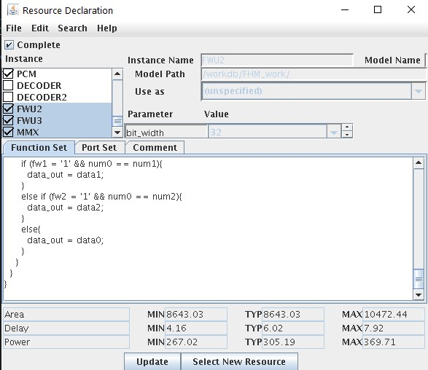

1. Then, create a new instruction formats with two input and two output registers. And create two different instructions which will use existing and new resources respectively.

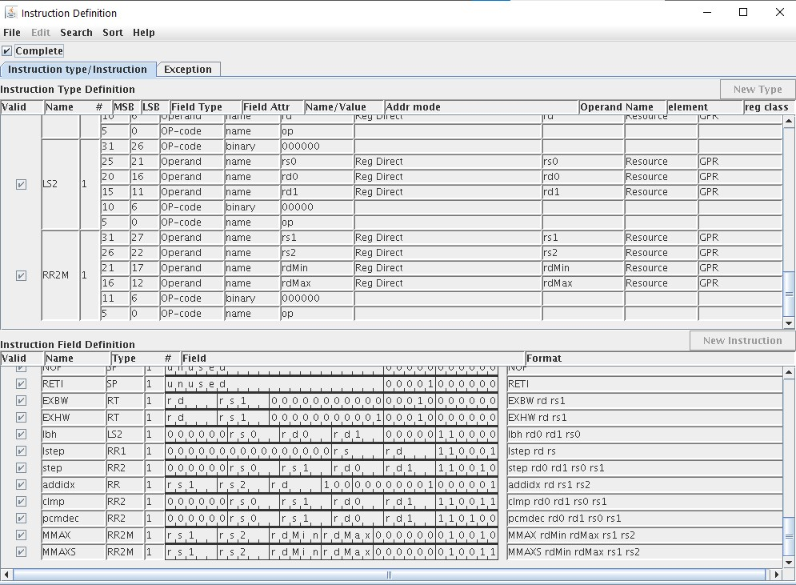

1. The Micro-Op description for the instruction MMAXS, which will be using the existing resources of ASIPmeister.

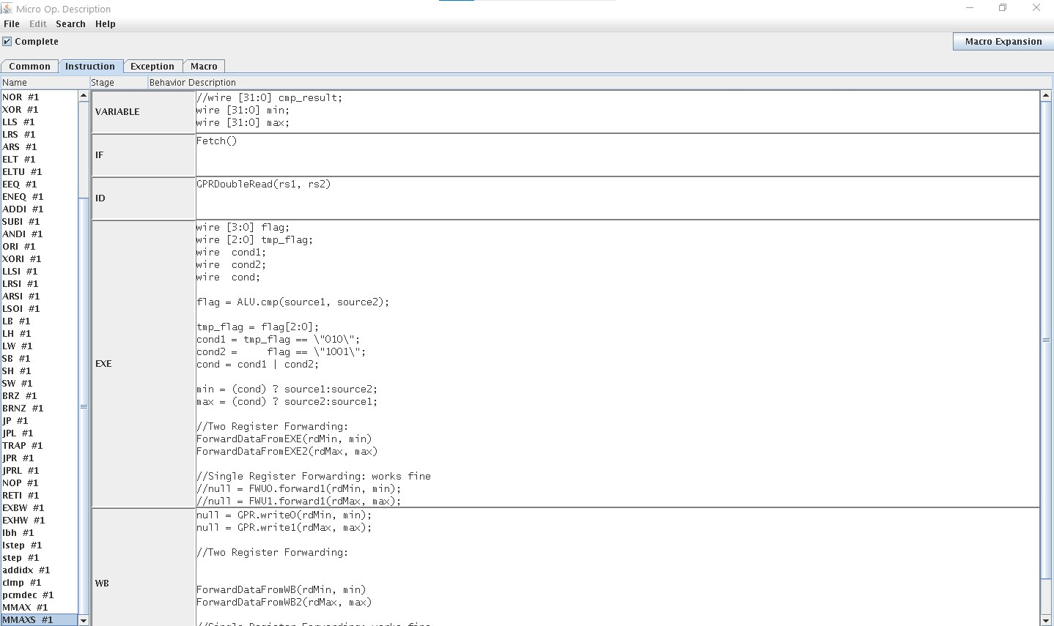

### USING NEW RESOURCES

1. The Micro-Op description for the instruction **MMAX**, which will be using the new resource **MMX** of ASIPmeister.

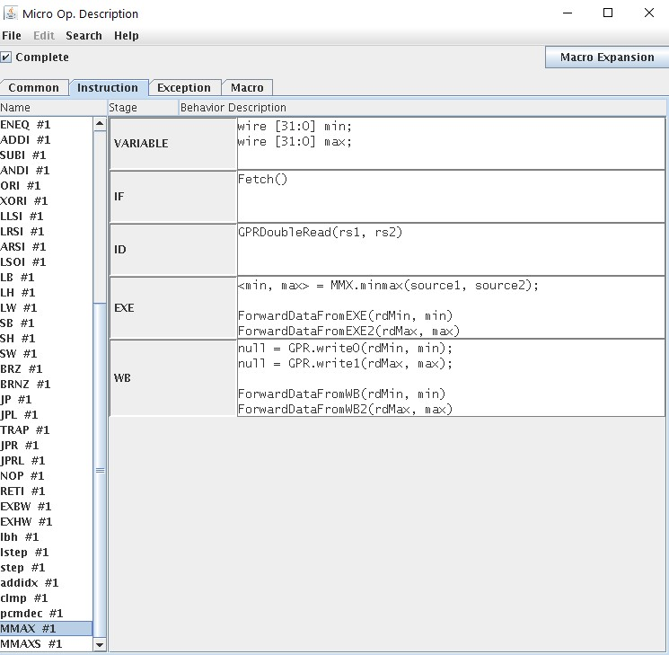

1. C Definition may look like this.

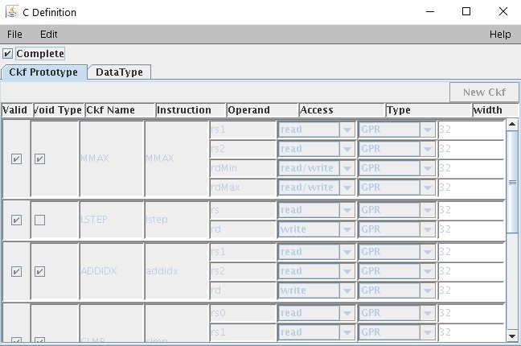

1. Generate the required compiler and VHDL files. A “***meister***” directory will be created in your ASIP project directory i.e. in “***brownie***”
2. Create a ModelSim project in the relevant directory of the current project, compile it and make it ready for the simulation.

## USING INSTRUCTIONS

1. Goto the “Applications” folder and create different applications to test each.

### ORIGINAL APPLICATION

sajjad@i80pc57:~/SS21/ASIPMeisterProjects/8/ brownie/Applications/ testMinMaxAPP:$ vim test.c

#### testMinMaxAPP/test.c

#define max(a, b) ( (a)>(b) ? (a):(b) )

#define min(a, b) ( (a)<(b) ? (a):(b))

unsigned int A[10] = { 32, 45, 0,0,0,0,0,0,0};

int main() {

A[4] = max(A[0], A[1]); // Maximum

A[5] = min(A[0], A[1]); // Minimum

return 0;

}

### APPLICATION WITH MMAXS (Existing Resources)

sajjad@i80pc57:~/SS21/ASIPMeisterProjects/8/ brownie/Applications/ testMinMaxSW:$ vim test.c

#### testMinMaxSW/test.c

unsigned int A[10] = { 32, 45, 0,0,0,0,0,0,0};

int main() {

__asm__ volatile (

"mmaxs %[out1], %[out2], %[op1], %[op2]\n\t"

: [out1] "=&r" (A[5]), [out2] "=&r" (A[4])

: [op1] "r" (A[0]), [op2] "r" (A[1])

);

return 0;

}

### APPLICATION WITH MMAX (New Resources)

sajjad@i80pc57:~/SS21/ASIPMeisterProjects/8/ brownie/Applications/ testMinMaxHW:$ vim test.c

#### testMinMaxHW/test.c

unsigned int A[10] = { 32, 45, 0,0,0,0,0,0,0};

int main() {

__asm__ volatile (

"mmax %[out1], %[out2], %[op1], %[op2]\n\t"

: [out1] "=&r" (A[5]), [out2] "=&r" (A[4])

: [op1] "r" (A[0]), [op2] "r" (A[1])

);

return 0;

}

### MODELSIM SIMULATIONS

1. ModelSim simulations produces following values:

testMinMaxAPP

-----------------

# ** Failure: SUCCESSFUL: Simulation End.

# Time: 2205 ns Iteration: 0 Process: /test/dmem File: /home/sajjad/SS21/ASIPMeisterProjects/8/dlx_opt_performance_1/ModelSim/tb_browstd32.vhd

# Break in Process dmem at /home/sajjad/SS21/ASIPMeisterProjects/8/dlx_opt_performance_1/ModelSim/tb_browstd32.vhd line 603

testMinMaxSW

-----------------

# ** Failure: SUCCESSFUL: Simulation End.

# Time: 1195 ns Iteration: 0 Process: /test/dmem File: /home/sajjad/SS21/ASIPMeisterProjects/8/dlx_opt_performance_1/ModelSim/tb_browstd32.vhd

# Break in Process dmem at /home/sajjad/SS21/ASIPMeisterProjects/8/dlx_opt_performance_1/ModelSim/tb_browstd32.vhd line 603

testMinMaxHW

-----------------

# ** Failure: SUCCESSFUL: Simulation End.

# Time: 1195 ns Iteration: 0 Process: /test/dmem File: /home/sajjad/SS21/ASIPMeisterProjects/8/dlx_opt_performance_1/ModelSim/tb_browstd32.vhd

# Break in Process dmem at /home/sajjad/SS21/ASIPMeisterProjects/8/dlx_opt_performance_1/ModelSim/tb_browstd32.vhd line 603